IT5512- WEB TECHNOLOGY LAB-SESSION-3
DATE: 20/09/2021 FN
NAME: A.S. PRUTHIEV
REG NO.2019506067
JAVA INHERITANCE AND POLYMORPHISM PROGRAMS

1) AIM:
To write a single level inheritance java program.

ALGORITHM:
- Create a class Student with private varaibles name,roll number,gender
- Create a constructor intializing the values
- Create a getter methods for each variables
- Create another classs Resut which extends Student whch has double cgpa ,and an array of marks
- Create a constructor which calls the super constructor and intializes the marks array
- Overload the toString method to return the result accordingly
- Create a method calculate cgpa which does the operation and stores the result in the cgpa variable.

PROGRAM CODE:

package Java.Lab.lab3;

import java.util.ArrayList;
import java.util.Scanner;

class Student{
private String name,rollNumber,gender;
int age;
public Student(String name, String rollNumber, String gender, int age) {
this.name = name;
this.rollNumber = rollNumber;
this.gender = gender;
this.age = age;
}
public String getName() {
return name;
}
public String getRollNumber() {
return rollNumber;
}
public String getGender() {
return gender;
}
public int getAge() {
return age;
}
}
class Result extends Student{
private double cgpa;
ArrayList<Integer>marks;
Result(String name,String rollNumber,String gender,int age,ArrayList<Integer>marks){
super(name,rollNumber,gender,age);
this.marks = marks;
}
void calculateCGPA(){
cgpa = marks.stream().mapToInt(x -> x).average().orElse(-1);
}
@Override
public String toString() {
return getName() + " " + getRollNumber() + " " + getAge() + " " + getGender() + " " + marks.toString() + " " + cgpa;
}
}
public class SingleLevelInheritance {
private static final Scanner input = new Scanner(System.in);
public static void main(String[] args) {
int n;
String name,rollNumber,gender;
int age;
System.out.print("Enter the number of students :");
n = input.nextInt();
ArrayList<Result>students = new ArrayList<>();
for(int i = 0 ; i < n ; i++){
input.nextLine();
System.out.print("Enter name :");
name = input.nextLine();
System.out.print("Enter roll number , gender , age :");
rollNumber = input.next();
gender = input.next();
age = input.nextInt();
int numMarks;
System.out.print("Enter the number of subjects :");
numMarks = input.nextInt();
System.out.print("Enter marks :");
ArrayList<Integer>marks = new ArrayList<>();
for(int j = 0 ; j < numMarks ; j++){
int m = input.nextInt();
marks.add(m);
}
students.add(new Result(name,rollNumber,gender,age,marks));
students.get(i).calculateCGPA();
}
for(int i = 0 ; i < n ; i++){
System.out.println(students.get(i));
}
}
}

OUTPUT:

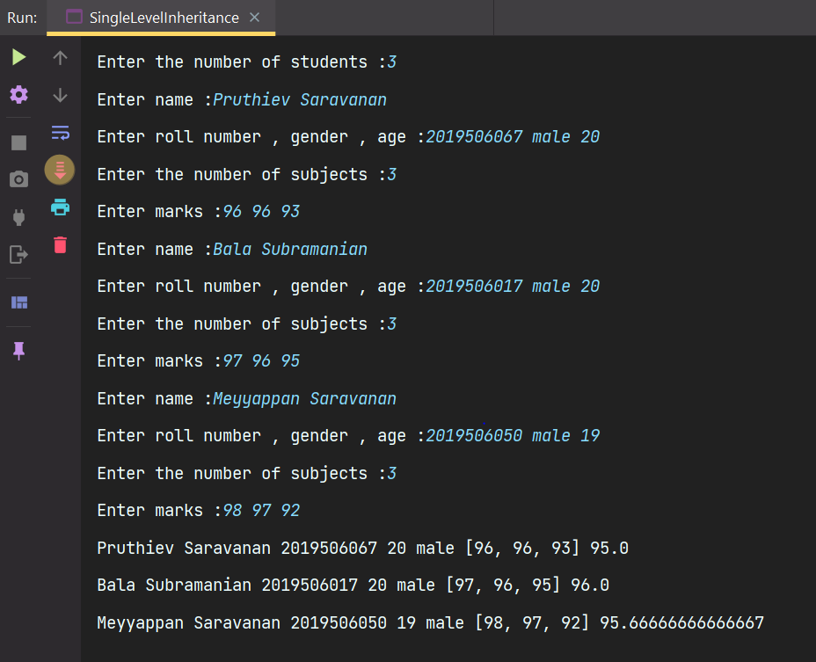

RESULT:
Thus, the program has been executed successfully.

2)
AIM:
To Write a Multilevel inheritance java program

ALGORITHM:

- Create a player class with name,state,country,age
- Create a constructor which intializes the variables and getter methods
- Create a Gamelevel class which extends player with fields like level,numberof matches,yearsofexperience
- Create a constructor which calls the super and intializes the variables and getter methods
- Create a Chess player class which inturn extends from Gamelevel with fields like totalRating,BlitzRating,rapidRating,classicalRating
- Create a constructor which calls the super and intializes the variables and getter methods
- Calculate the totalRating and return the level according to the condition

PROGRAM CODE

package Java.Lab.lab3;

import java.util.ArrayList;
import java.util.Scanner;

class Player{
private String name,state,country;
private int age;
public Player(String name, String state, String country,int age) {
this.name = name;
this.state = state;
this.country = country;
this.age = age;
}
public String getName() {
return name;
}
public String getState() {
return state;
}
public String getCountry() {
return country;
}
public int getAge() {
return age;
}
}
class GameLevel extends Player{
protected String level;
int numberOfMatches;
int yearsOfExperience;
public GameLevel(String name, String state, String country,int age, int numberOfMatches, int yearsOfExperience) {
super(name, state, country,age);
this.numberOfMatches = numberOfMatches;
this.yearsOfExperience = yearsOfExperience;
}
public String getLevel() {
return level;
}
public int getNumberOfMatches() {
return numberOfMatches;
}
public int getYearsOfExperience() {
return yearsOfExperience;
}
}
class ChessPlayer extends GameLevel{
double blitzRating , rapidRating , classicalRating,totalRating;
public ChessPlayer(String name, String state, String country,int age,int numberOfMatches,int yearsOfExperience,double blitzRating, double rapidRating, double classicalRating) {
super(name,state,country,age,numberOfMatches,yearsOfExperience);
this.blitzRating = blitzRating;
this.rapidRating = rapidRating;
this.classicalRating = classicalRating;
this.totalRating = (this.blitzRating + this.rapidRating + this.rapidRating)/3;
}
public double getBlitzRating() {
return blitzRating;
}
public double getRapidRating() {
return rapidRating;
}
public double getClassicalRating() {
return classicalRating;
}
public void determineLevel(){
if(totalRating >=0 && totalRating <=1500)level = "Beginner";
else if(totalRating > 1500 && totalRating <= 1800)level = "Expert";
else if(totalRating > 1800 && totalRating <= 2000)level = "Specialist";
else if(totalRating > 2000 && totalRating <= 2300)level = "Candidate Master";
else if(totalRating > 2300 && totalRating <= 2500)level = "Master";
else if(totalRating > 2500 && totalRating <= 2700)level = "Grandmaster";
else if(totalRating > 2700 && totalRating <= 2900)level = "International Grandmaster";
else level = "Legendary Grandmaster";
}

@Override
public String toString() {
return getName() + " " + getAge() + " " + getState() + " " + getCountry() + " " +
getLevel() + " " + getNumberOfMatches() + " " + getYearsOfExperience() + " " +
totalRating;
}
}
public class MultilevelInheritance {
private static final Scanner input = new Scanner(System.in);
public static void main(String[] args) {
int n;
String name,state,country;
int age ,numberOfMatches,yearsOfExperience;
double blitzRating , rapidRating , classicalRating;
System.out.print("Enter the number of chess players :");
n = input.nextInt();
ArrayList<ChessPlayer>chessPlayers = new ArrayList<>();
for(int i = 0 ; i < n ; i ++){
input.nextLine();
System.out.print("Enter name :");
name = input.nextLine();
System.out.print("Enter state,country :");
state = input.next();
country = input.next();
System.out.print("Enter age , number of matches , years of experience: ");
age = input.nextInt();
numberOfMatches = input.nextInt();
yearsOfExperience = input.nextInt();
System.out.print("Enter the ratings in : Blitz , Rapid , Classical :");
blitzRating = input.nextInt();
rapidRating = input.nextInt();
classicalRating = input.nextInt();
chessPlayers.add(new ChessPlayer(name,state,country,age,numberOfMatches,yearsOfExperience,blitzRating,rapidRating,classicalRating));
chessPlayers.get(i).determineLevel();
}
for(int i = 0; i < n ; i++){
System.out.println(chessPlayers.get(i));
}
}
}

OUTPUT:
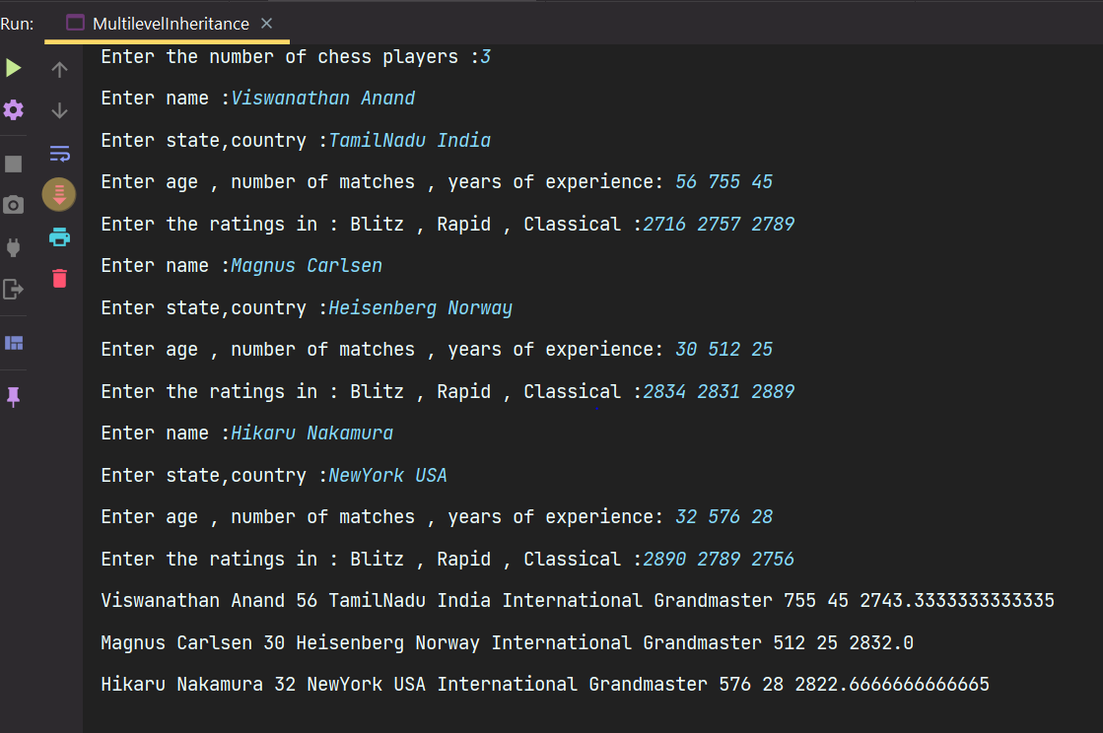

RESULT:
Thus, the program has been executed successfully.
3)AIM :
To Write a Hierarchical Inheritance java progam

ALGORITHM:
- Create pair class with data members like name,points .create a constructor and getter methods
- Create a class Cricket with fields like format , numOvers,numberofdays
- Creata a constructor Cricket which intializes the variables and getter methods
- Create a class TestCricket which inherits from Cricket with fields like Pair teams[] ,name, points
- Create a contructor which intializes the variables and enter the three team names and their points
- Create a sortData method which sort the names of the teams according to the points
- Similarly create a class for ODICrciket and T20Cricket which inherites from Cricket and repeat the same operations as we did it in the TestCricket class
- Create an object of the TestCricket , ODICricket,T20Cricket and call the sortdata methods an finally print it.

PROGRAM CODE :

package Java.Lab.lab3;
import java.util.Arrays;
import java.util.Comparator;
import java.util.Scanner;
class Pair{
private String name;
double points;
public Pair(String name, double points) {
this.name = name;
this.points = points;
}
public String getName() {
return name;
}
public double getPoints() {
return points;
}
@Override
public String toString() {
return "Name :" + name + " Points :" + points;
}
}
class Cricket{
protected String format;
int numOvers ,numberOfDays;
public Cricket(String format, int numOvers, int numberOfDays) {
this.format = format;
this.numOvers = numOvers;
this.numberOfDays = numberOfDays;
}
public String getFormat() {
return format;
}
public int getNumOvers() {
return numOvers;
}
public int getNumberOfDays() {
return numberOfDays;
}
}
class TestCricket extends Cricket{
Pair []teams;
String name;
double points;
private final Scanner input = new Scanner(System.in);
public Pair getValues(){
System.out.print("Enter name :");
name = input.nextLine();
System.out.print("Enter points :");
points = input.nextDouble();
Pair value = new Pair(name,points);
return value;
}
public TestCricket(String format, int numOvers, int numberOfDays) {
super(format, numOvers, numberOfDays);
System.out.println("TEST CRICKETS");
teams = new Pair[3];
System.out.println("TEAMS");
for(int i = 0 ; i < 3 ; i++){
teams[i] = getValues();
input.nextLine();
}
}
public void sortData(){
Arrays.sort(teams, Comparator.comparing(Pair :: getPoints).reversed());
}
@Override
public String toString(){
return teams[0].toString() +" " + teams[1].toString() + " " + teams[2].toString() + "\n" ;
}
}
class ODICricket extends Cricket{
Pair [] teams;
String name;
double points;
private final Scanner input = new Scanner(System.in);
public Pair getValues(){
System.out.print("Enter name :");
name = input.nextLine();
System.out.print("Enter points :");
points = input.nextDouble();
Pair value = new Pair(name,points);
return value;
}
public ODICricket(String format, int numOvers, int numberOfDays) {
super(format, numOvers, numberOfDays);
System.out.println("ODI CRICKETS");
teams = new Pair[3];
System.out.println("TEAMS");
for(int i = 0 ; i < 3 ; i++){
teams[i] = getValues();
input.nextLine();
}
}
public void sortData(){
Arrays.sort(teams, Comparator.comparing(Pair :: getPoints));
}
@Override
public String toString(){
return teams[0].toString() +" " + teams[1].toString() + " " + teams[2].toString() + "\n" ;
}
}
class T20Cricket extends Cricket{
Pair [] teams;
String name;
double points;
private final Scanner input = new Scanner(System.in);
public Pair getValues(){
System.out.print("Enter name :");
name = input.nextLine();
System.out.print("Enter points :");
points = input.nextDouble();
Pair value = new Pair(name,points);
return value;
}
public T20Cricket(String format, int numOvers, int numberOfDays) {
super(format, numOvers, numberOfDays);
System.out.println("T20 CRICKETS");
teams = new Pair[3];
System.out.println("TEAM");
for(int i = 0 ; i < 3 ; i++){
teams[i] = getValues();
input.nextLine();
}
}
public void sortData() {
Arrays.sort(teams, Comparator.comparing(Pair::getPoints));
}
@Override
public String toString(){
return teams[0].toString() +" " + teams[1].toString() + " " + teams[2].toString() + "\n" ;
}
}
public class HierarchicalInheritance {
public static void main(String[] args) {
TestCricket testCricket = new TestCricket("Test" ,90,5);
ODICricket odiCricket = new ODICricket("ODI" ,50,1);
T20Cricket t20Cricket = new T20Cricket("T20" , 20,1);
testCricket.sortData();
System.out.print(testCricket);
odiCricket.sortData();
System.out.print(odiCricket);
t20Cricket.sortData();
System.out.print(t20Cricket);
}
}

OUTPUT:

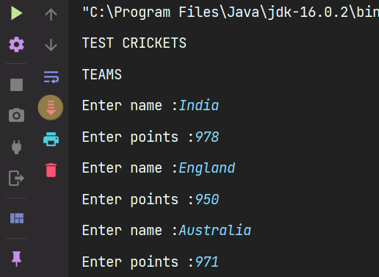

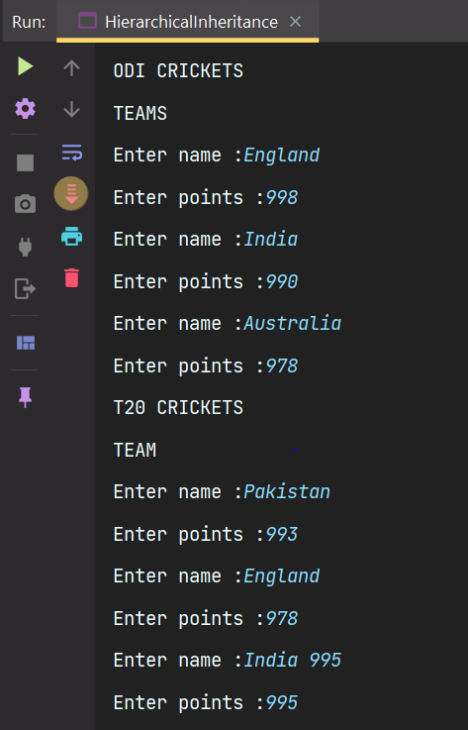
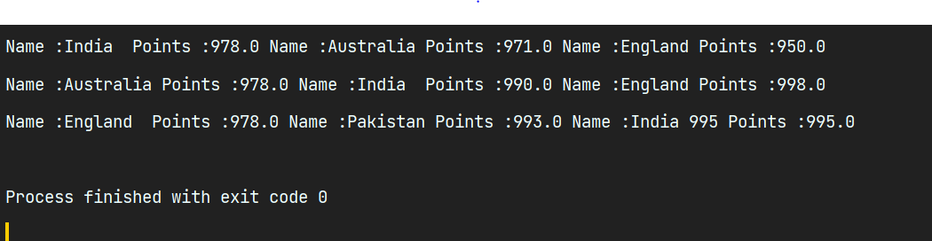

RESULT:
Thus, the program has been executed successfully.
MULTIPLE INHERITANCE IN JAVA :

- Multiple Inheritance is a feature of an object-oriented concept, where a class can inherit properties of more than one parent class.

- The problem occurs when there exist methods with the same signature in both the superclasses and subclass.

- On calling the method, the compiler cannot determine which class method to be called and even on calling which class method gets the priority.

- Multiple inheritance is not supported by Java using classes, handling the complexity that causes due to multiple inheritances is very complex.

- It creates problems during various operations like casting, constructor chaining, etc, and the above all reason is that there are very few scenarios on which we actually need multiple inheritances, so better to omit it for keeping things simple and straightforward.

SOLUTION :
- Java 8 supports default methods where interfaces can provide a default implementation of methods.

- And a class can implement two or more interfaces.

- In case both the implemented interfaces contain default methods with the same method signature, the implementing class should explicitly specify which default method is to be used, or it should override the default method.

4)AIM :
To Write a polymorphism program in java

ALGORITHM:
- Create a class ProgrammingLanguage with fields like languagname,founder,speed,typed
- Create a constructor which initializes the variables and getter methods
- Create a class Cplus Cplus which inherits from ProgrammingLanguage and overides the methods in the base class
- Similarly create a class for Java,Python and which all these classes inherits from ProgrammingLanguage and overides the base class methods accordingly
- Create a object of the base class that is Programming language run a loop for 5 times and create a random number and call the classes accordingly

PROGRAM CODE :

package Java.Lab.lab3;
class ProgrammingLanguage{
protected String languageName,founder,speed;
protected String typed;
int year;
public ProgrammingLanguage(String languageName, String founder,int year) {
this.languageName = languageName;
this.founder = founder;
this.year = year;
}
public String speed(){
return "The speed is very very slow";
}
public String getLanguageName() {
return languageName;
}
public String getFounder() {
return founder;
}
public String getTyped() {
return "Machine level typed";
}
public int getYear() {
return year;
}
public String application(){
return "The application depends upon the language :";
}

@Override
public String toString() {
return getFounder() + " " + getLanguageName() + " "+ getTyped() + " " + application();
}
}
class CPlusPlus extends ProgrammingLanguage{
public CPlusPlus(String languageName, String founder,int year) {
super(languageName, founder, year);
}
@Override
public String getLanguageName() {
return languageName;
}
@Override
public String getFounder() {
return founder;
}
@Override
public String speed() {
return "Faster than Python and Java";
}
@Override
public String getTyped() {
return "Statistically Typed";
}
@Override
public int getYear() {
return year;
}
@Override
public String application() {
return " -> C++ is used is a lot of operating systems (Mac OS and Linux as well). Windows OS is a mix of C and C++.\n"+
" -> YouTube is written in a few different languages However,\n"+
" -> C++ was used for the most important and core function of this app – video processing.\n"+
" -> Managing this many data is extremely difficult when your site has approximately between to 2 billion monthly users.\n"+
" -> I think it speaks for itself. C++ is a secret weapon of the biggest companies in the world.\n";
}
@Override
public String toString() {
return "Founder :" + getFounder() + "\n" +"Language :" + getLanguageName() + "\n"+ "Typed : " + getTyped() + "\n" + application();
}
}
class Python extends ProgrammingLanguage{
public Python(String languageName, String founder, int year) {
super(languageName, founder, year);
}
@Override
public String getLanguageName() {
return languageName;
}
@Override
public String speed() {
return "Python is slower than java and C++";
}
@Override
public String getFounder() {
return founder;
}
@Override
public String getTyped() {
return "Dynamically Typed";
}
@Override
public int getYear() {
return year;
}
@Override
public String application() {
return " -> Python is used in web development where in Django ,flask are the most used frameworks\n"+
" -> It is used in Machine learning where in the libraries like Numpy , Pandas ,Tensorflow, keras are used\n"
+" -> It is also used in Data science along with R\n";
}
@Override
public String toString() {
return "Founder :" + getFounder() + "\n" +"Language :" + getLanguageName() + "\n"+ "Typed : " + getTyped() + "\n" + application();
}
}
class Java extends ProgrammingLanguage{
public Java(String languageName, String founder, int year) {
super(languageName, founder,year);
}
@Override
public String speed() {
return "Faster than Python but slower than C++";
}
@Override
public String getLanguageName() {
return languageName;
}
@Override
public String getFounder() {
return founder;
}
@Override
public String getTyped() {
return "Statistically Typed";
}
@Override
public int getYear() {
return year;
}
@Override
public String application() {
return " -> Java is used in Web development as backend support where in Maven , Spring , Spring MVC are used\n"+
" -> It has connectivity with the databases like SQLite , MYSQL , Postgres\n" +
" -> It is used in Android Development with Android XMl and Android Studio\n" +
" -> It is to create Desktop Applications using JAVAFX and JAVAFX xml\n";
}
@Override
public String toString() {
return "Founder :" + getFounder() + "\n" +"Language :" + getLanguageName() + "\n"+ "Typed : " + getTyped() + "\n" + application();
}
}
public class Polymorphism1 {
public static void main(String[] args) {
ProgrammingLanguage programmingLanguage = new ProgrammingLanguage("Assembly Language" , "Dennis Ritchie",1700);
for(int i = 0 ; i < 5 ; i ++){
int randomNumber = (int)((Math.random()*3)+1);
switch(randomNumber){
case 1 -> {
programmingLanguage = new CPlusPlus("C ++","Bjarne Stroustrup",1900);
System.out.println(programmingLanguage.toString());
break;
}
case 2 ->{
programmingLanguage = new Python("Python" , "Guido van Rossum",1975);
System.out.println(programmingLanguage.toString());
break;
}
case 3 -> {
programmingLanguage = new Java("Java","James Gosling",1990);
System.out.println(programmingLanguage.toString());
break;
}
default -> {
System.out.println("Invalid Language !!!!");
System.out.println(programmingLanguage.toString());
}
}
}
}
}

OUTPUT:
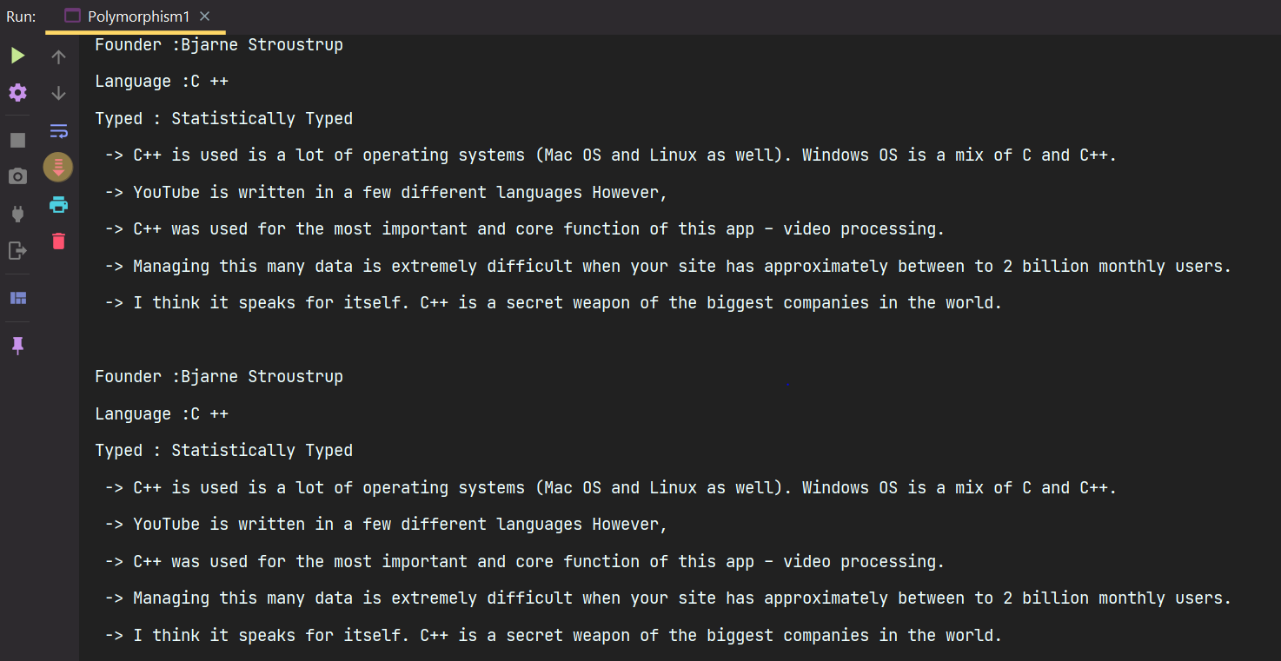

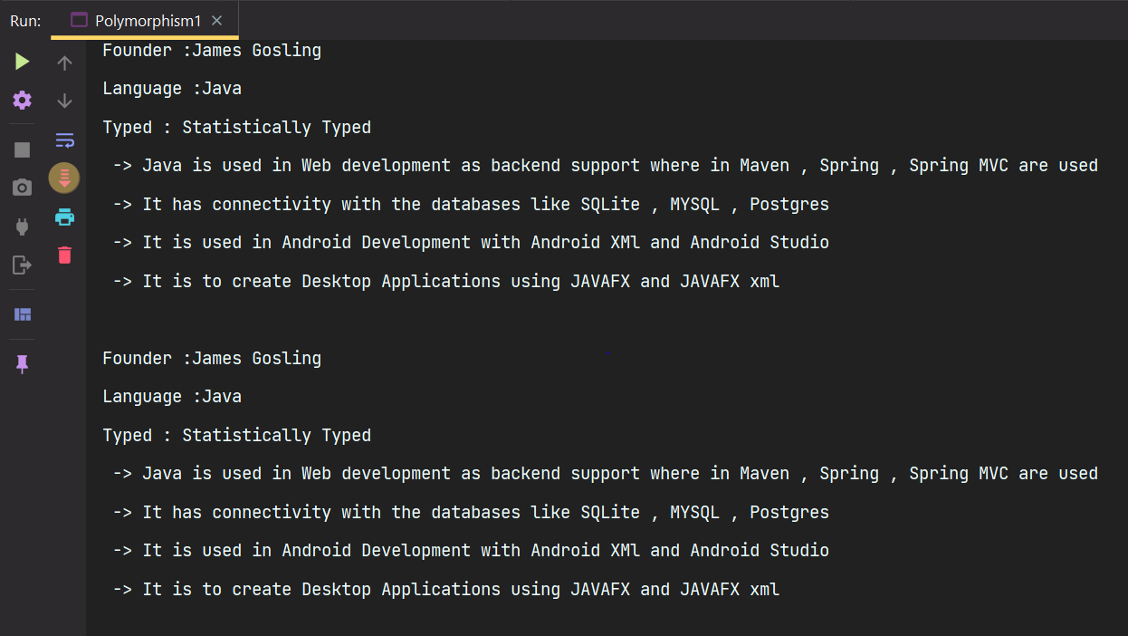
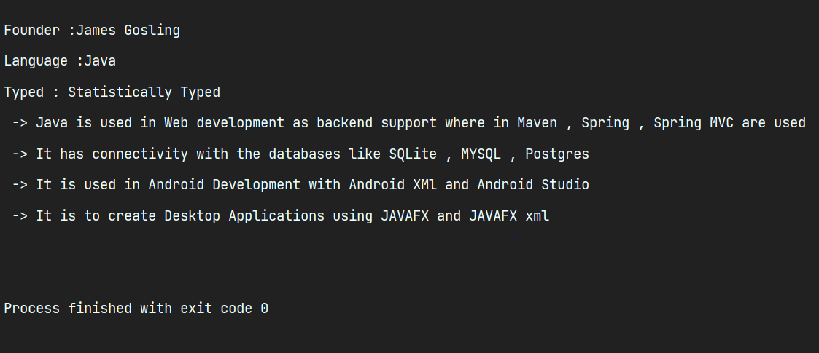

RESULT:
Thus, the program has been executed successfully.

AIM :
To Write a polymorphism program in java

ALGORITHM:
- Create a class Color with fields like colorString,color
- Create constructor which intializes the variables and getter methods
- Create a class Green that extends from Programming Language in which the constructor
Call the super and intializes the variables and getter methods which inturn prints the content in that particular color
- Create a class for other color like Blue , Purple , Red , Cyan which inherits from Color class and prints the content in that particular color.

PROGRAM CODE:

package Java.Lab.lab3;
class Color{
protected String colorString,color;
public Color(String colorString, String color) {
this.colorString = colorString;
this.color = color;
}
public String getColorString() {
return colorString;
}
public String getColor() {
return color;
}
@Override
public String toString() {
return color + "The color written is :" + colorString + " Ansi value is :" + getColor();
}
}
class Green extends Color{
public Green(String colorString, String color) {
super(colorString, color);
}
@Override
public String getColorString() {
return super.getColorString();
}
@Override
public String getColor() {
return super.getColor();
}
@Override
public String toString() {
return color + "The color written is :" + colorString;
}
}
class Blue extends Color{
public Blue(String colorString, String color) {
super(colorString, color);
}
@Override
public String getColorString() {
return super.getColorString();
}
@Override
public String getColor() {
return super.getColor();
}
@Override
public String toString() {
return color + "The color written is :" + colorString;
}
}
class Purple extends Color{
public Purple(String colorString, String color) {
super(colorString, color);
}
@Override
public String getColorString() {
return super.getColorString();
}
@Override
public String getColor() {
return super.getColor();
}
@Override
public String toString() {
return color + "The color written is :" + colorString;
}
}
class Red extends Color{
public Red(String colorString, String color) {
super(colorString, color);
}
@Override
public String getColorString() {
return super.getColorString();
}
@Override
public String getColor() {
return super.getColor();
}
@Override
public String toString() {
return color + "The color written is :" + colorString;
}
}
class Cyan extends Color{
public Cyan(String colorString, String color) {
super(colorString, color);
}
@Override
public String getColorString() {
return super.getColorString();
}
@Override
public String getColor() {
return super.getColor();
}
@Override
public String toString() {
return color + "The color written is :" + colorString;
}
}
public class Polymorpshism2 {
public static void main(String[] args) {
Color color = new Color("Black","\u001B[30m");
for(int i = 0 ; i < 10 ; i++){
int randomNumber = (int)((Math.random()*5)+1);
switch (randomNumber){
case 1 -> {
color = new Green("Green","\u001B[32m");
System.out.println(color);
}
case 2 -> {
color = new Purple("Purple","\u001B[35m");
System.out.println(color);
}
case 3 -> {
color = new Blue("Blue" , "\u001B[34m");
System.out.println(color);
}
case 4 -> {
color = new Red("Red" , "\u001B[31m");
System.out.println(color);
}
case 5 -> {
color = new Cyan("Cyan" , "\u001B[36m");
System.out.println(color);
}
default -> {
System.out.println("Invalid Color!!!!");
}
}
}
}
}
OUTPUT:
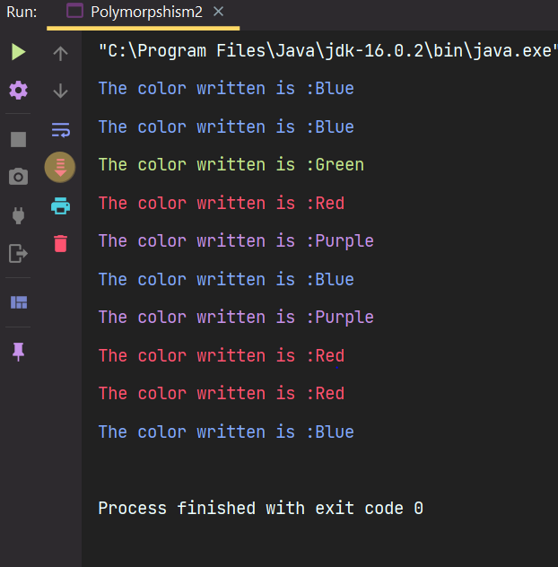

RESULT:
Thus, the program has been executed successfully.
Early Binding vs Late Binding

COMPILE TIME POLYMORPHISM | RUN TIME POLYMORPHSIM
- In Compile time Polymorphism, the call is resolved by the compiler.  - It is also known as Static binding, Early binding and overloading as well.  - Method overloading is the compile-time polymorphism where more than one methods share the same name with different parameters or signature and different return type.  - It is achieved by function overloading and operator overloading.  - It provides fast execution because the method that needs to be executed is known early at the compile time  - Compile time polymorphism is less flexible as all things execute at compile time. | - In Run time Polymorphism, the call is not resolved by the compiler.  - It is also known as Dynamic binding, Late binding and overriding as well.  - Method overriding is the runtime polymorphism having same method with same parameters or signature, but associated in different classes.  - It is achieved by overiding since all the objects are refernces no need to create pointers and virtual functions like c++  - It provides slow execution as compare to early binding because the method that needs to be executed is known at the runtime.  - Run time polymorphism is more flexible as all things execute at run time.

